Experiment 2
AIM: Design Employee Payroll System using Inheritance, Interface &
Polymorphism
Source: Program.cs

Code:
using System;

interface IPayroll
{
void CalculateSalary();
void DisplaySalary();
}

class Employee
{
public int EmpId;
public string Name;
public string Department;

public void GetDetails()
{
Console.Write("Enter Employee ID: ");
EmpId = Convert.ToInt32(Console.ReadLine());

Console.Write("Enter Employee Name: ");
Name = Console.ReadLine();

Console.Write("Enter Department: ");
Department = Console.ReadLine();
}
}

class FullTimeEmployee : Employee, IPayroll
{
public double BasicSalary;
public double HRA;
public double DA;
public double GrossSalary;
public double Tax;
public double NetSalary;

public void CalculateSalary()
{
Console.Write("Enter Basic Salary: ");
BasicSalary = Convert.ToDouble(Console.ReadLine());

HRA = BasicSalary * 0.20; // 20% HRA
DA = BasicSalary * 0.10; // 10% DA
GrossSalary = BasicSalary + HRA + DA;
Tax = GrossSalary * 0.05; // 5% Tax
NetSalary = GrossSalary - Tax;
}

public void DisplaySalary()
{
Console.WriteLine("\n========== EMPLOYEE PAYROLL ==========");
Console.WriteLine("Employee ID : " + EmpId);
Console.WriteLine("Employee Name : " + Name);
Console.WriteLine("Department : " + Department);
Console.WriteLine("--------------------------------------");
Console.WriteLine("Basic Salary : " + BasicSalary);
Console.WriteLine("HRA (20%) : " + HRA);
Console.WriteLine("DA (10%) : " + DA);
Console.WriteLine("Gross Salary : " + GrossSalary);
Console.WriteLine("Tax (5%) : " + Tax);
Console.WriteLine("Net Salary : " + NetSalary);
Console.WriteLine("======================================");
}
}

class Program
{
static void Main(string[] args)
{
IPayroll payroll = new FullTimeEmployee();

FullTimeEmployee emp = (FullTimeEmployee)payroll;

emp.GetDetails();

payroll.CalculateSalary();

payroll.DisplaySalary();

Console.ReadKey();
}
}

Output: Screenshot:

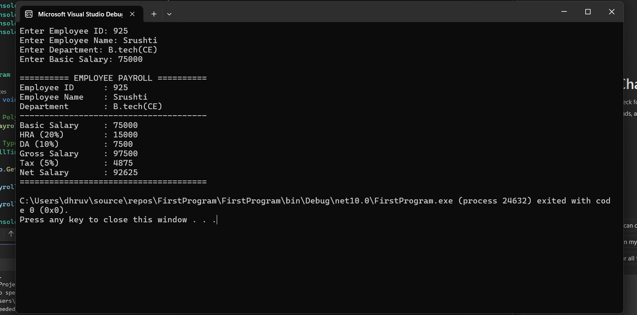

Github Link: https://github.com/Srushti-7745/Student-Management-Portal

